Myrmes: Colony Tiles Expansion

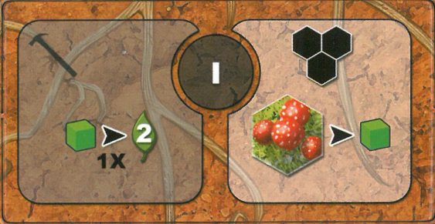
Level I
- Worker action: 1 food --1x--> 2 victory points
- Mushrooms are food when placing pheromone tile

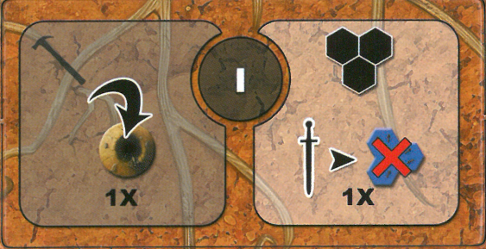
Level I
- Worker action: place / replace one tunnel (without getting earth)
- 1 virtual warrior per turn to step on enemy pheromones only

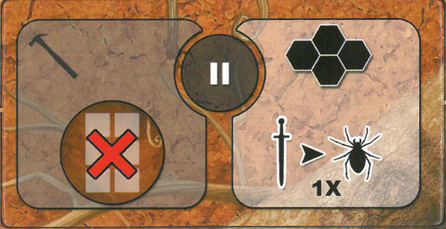
Level II
- Worker action: no discarding of excess cubes this turn
- 1 virtual warrior per turn to hunt prey only

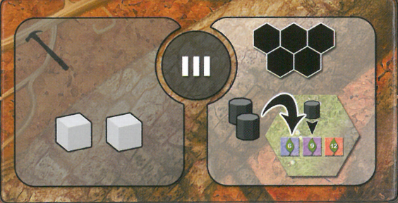
Level III
- Worker action: get 2 larvae
- Possibility to place 2 nurses on the objective atelier space

