Waypoints Map Germany Rules V1.3
Sightseeing in Germany

Copyright 2024 Dominik Wagenführ, distributed via Creative Commons Attribution-ShareAlike 4.0 license.

How to Play
This manual contains the additional rules for the fan made Waypoints Map „Sightseeing in Germany“. Please see the official Map 1 for the full rules of the game.

Weather Track
The weather track works as in the base game but starting in the top right. Each hike lasts one quarter of a calendar year. So, you are visiting Germany for one year, starting in January and ending in December. Note that the weather is accustomed to the average temperature in Germany at this point of time. So in July and August the weather is best – and you will have the most movement points available.

New Lines
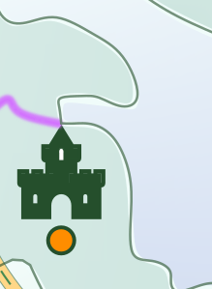
Coastal border: Crossing from land to sea or vice versa costs 1 movement point as normal contour lines.
In the example above it will costs 2 movement points to cross from Denmark to Germany via sea. Of course, it will costs 2 movement points as well if you just cross the border.
Note: Although Rügen in the north-east is an island it is connected to the mainload via a bridge in reality. So I decided to connect it via patch of land to get there.

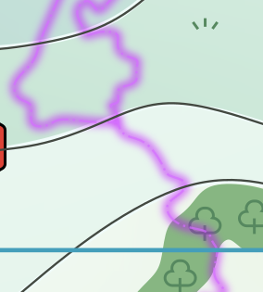
Country border: You can cross the country border by spending 2 movement points.

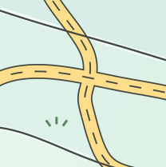
Autobahn: You can use the Autobahn only when using the Car Bonus (see below).
Crossing (not traveling) the Autobahn with normal movement will cost you 1 movement point.
Note: The numbers on the Autobahn are just flavor (yet).

New Waypoints
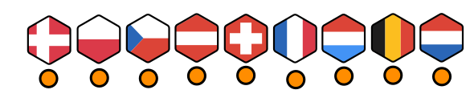
EU Country: When visiting an European country, just write the corresponding number below the Waypoint into the leftmost available square. If the space has a 2x under it, double the numbers value.

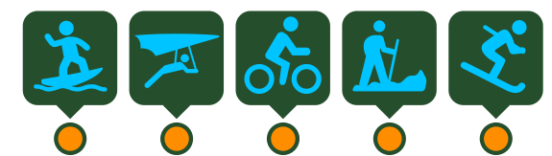
Leisure Activity: Circle the next available space on the track when visiting one of these waypoints.
Special Actions
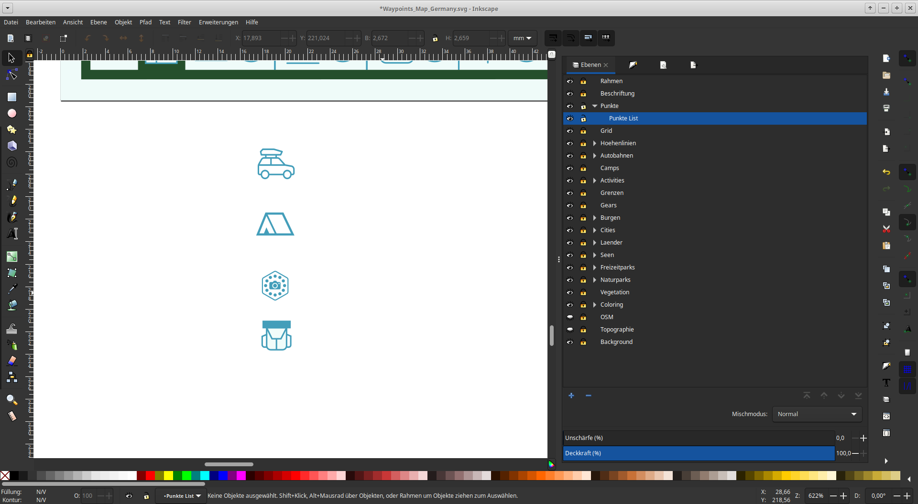
Car: By visiting Cities you can rent a Car. You can use a Car for travelling the Autobahn across up to 3 grid lines and borders for free this turn (the amount of contour lines crossed does not matter at all). You can use the Autobahn before, after or in between your regular movement, entering and exiting anywhere you like.
Tent: You can use a Tent only at the end of a single hike after reaching the last waypoint. You then can use the Tent to have an extra turn and use up to 2 movements points (plus additional water, Car bonus etc.) to go to an unused Campsite.
EU photo: Some fun parks (e.g. Europa-Park) offer smaller versions or sights from their neighboring countries. Immeditiately when you receive the bonus choose an unvisited EU country anywhere on the map. Cross off the small dot below this choosen waypoint – you cannot visit it again. Note the points for the EU country as usual. It seems to you as if you just have seen the country.
Note: Taking a photo of an attraction in a fun park does not count for Journal scoring.

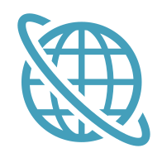

Internet Search: Best way to learn something that you cannot visit directly is an internet search. Immediately when you receive that bonus choose a waypoint that you haven’t visited in the same grid square or an orthogonally adjacent grid square. Cross off the small dot below this choosen waypoint – you cannot visit it again. Handle the waypoint as if you have just visited it.
Note: Internet search does not count for Journal scoring.

Backpack: You can use the Backpack as Car, Tent or EU photo bonus.

If you want to use the Backpack as EU photo bonus, you need to decide which Country to cross of immeditately when gaining the Backpack. You are not allowed to use the Backpack as EU photo bonus later in the game.

Features
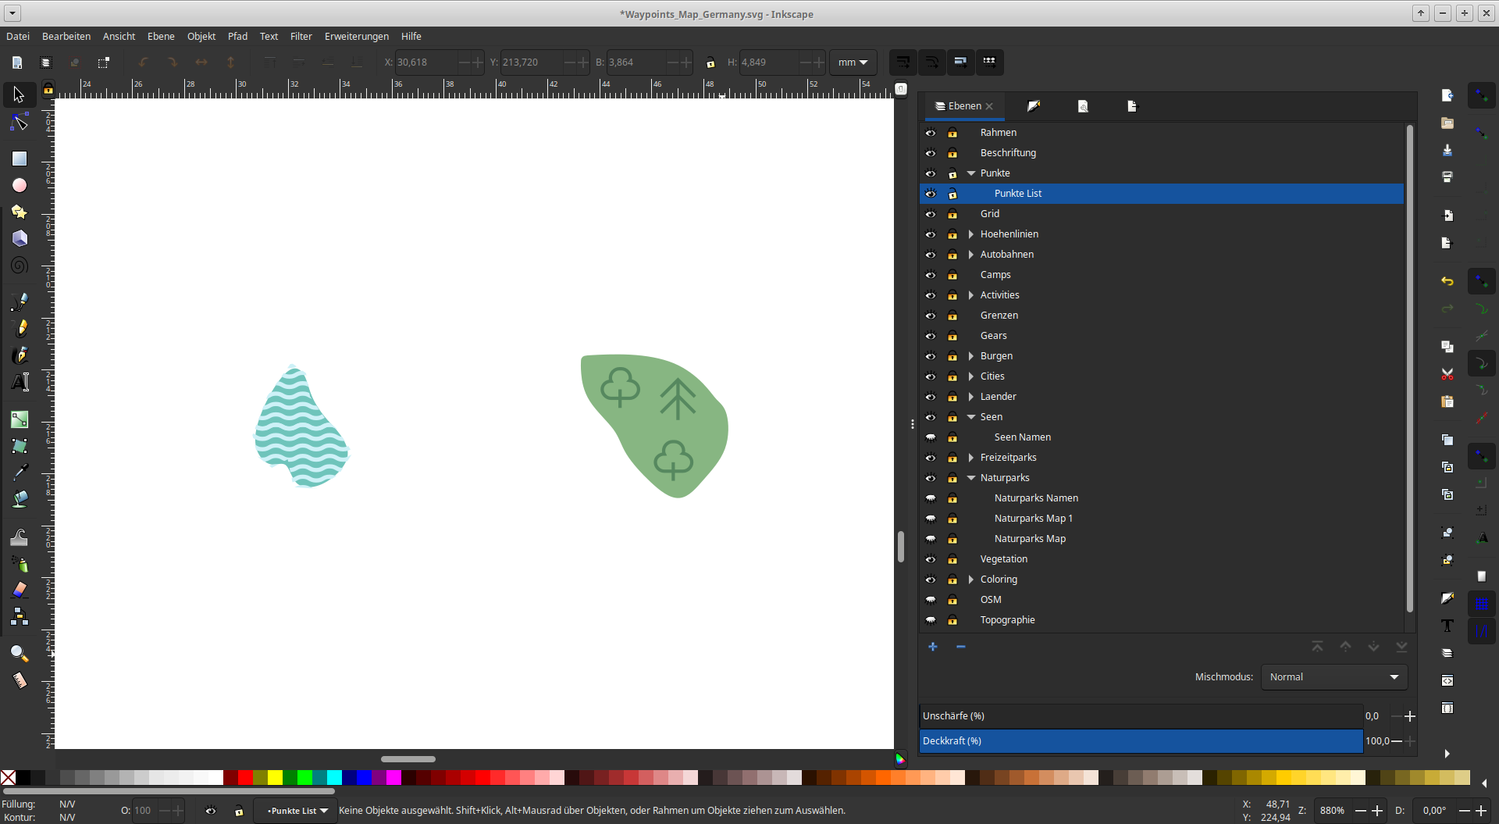
Lake: Gain 1 water as usual. You are not allowed to use the water in this turn, though.

National Park: You enjoy the forest so much that you have more energy. You immediately gain 2 more movement points that you can spend this turn only.
(Of course you will not see any Cities, Fun Parks or Castles when visiting the forest. That would almost be like seeing Dolphins in the woods.)
Note: If you visit a waypoint located inside a national park you should use the bonus when starting the next turn from it.
Note: You are not allowed to use the bonus movement points before reaching the forest. I.e., if you have 5 movements points and you need 6 to reach the forest, you need to spend 1 water to reach the forest and gain the bonus movement points. So plan ahead!

JournalS
Note: Waypoints you have taken a photo of or used an internet search are not taken into account.
Note: All EU countries are seen as the same waypoint type. The same applies to leisure activities.

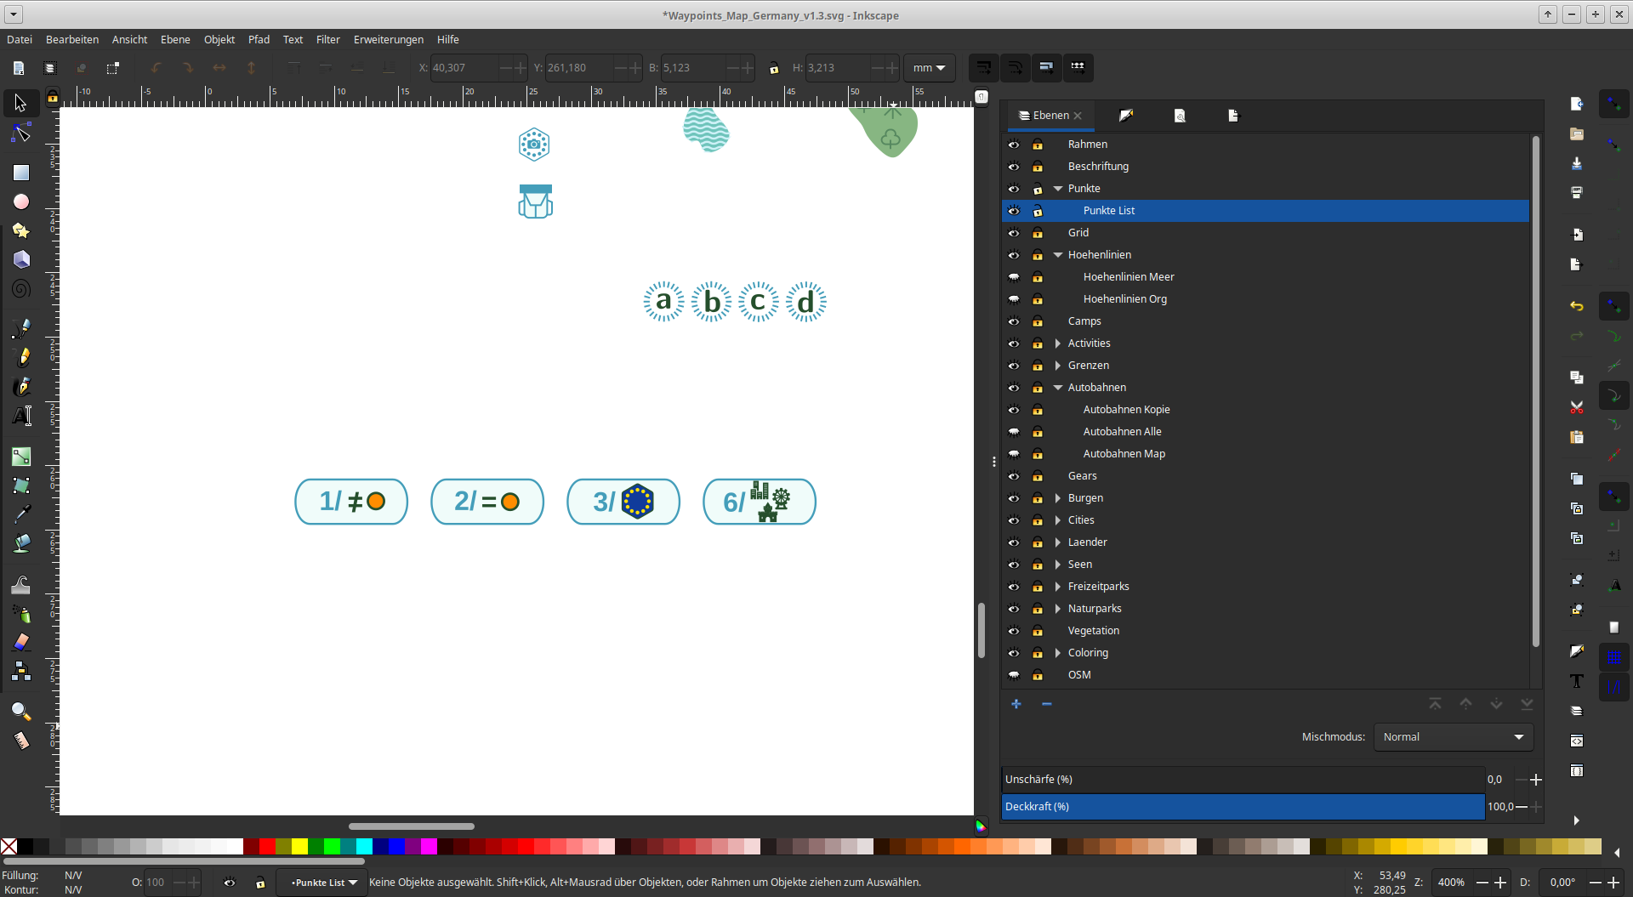
Score 1 point for each different point of waypoint visited on this hike.

Select one waypoint type. Score 2 points for each waypoint of this type you have visited on this hike.

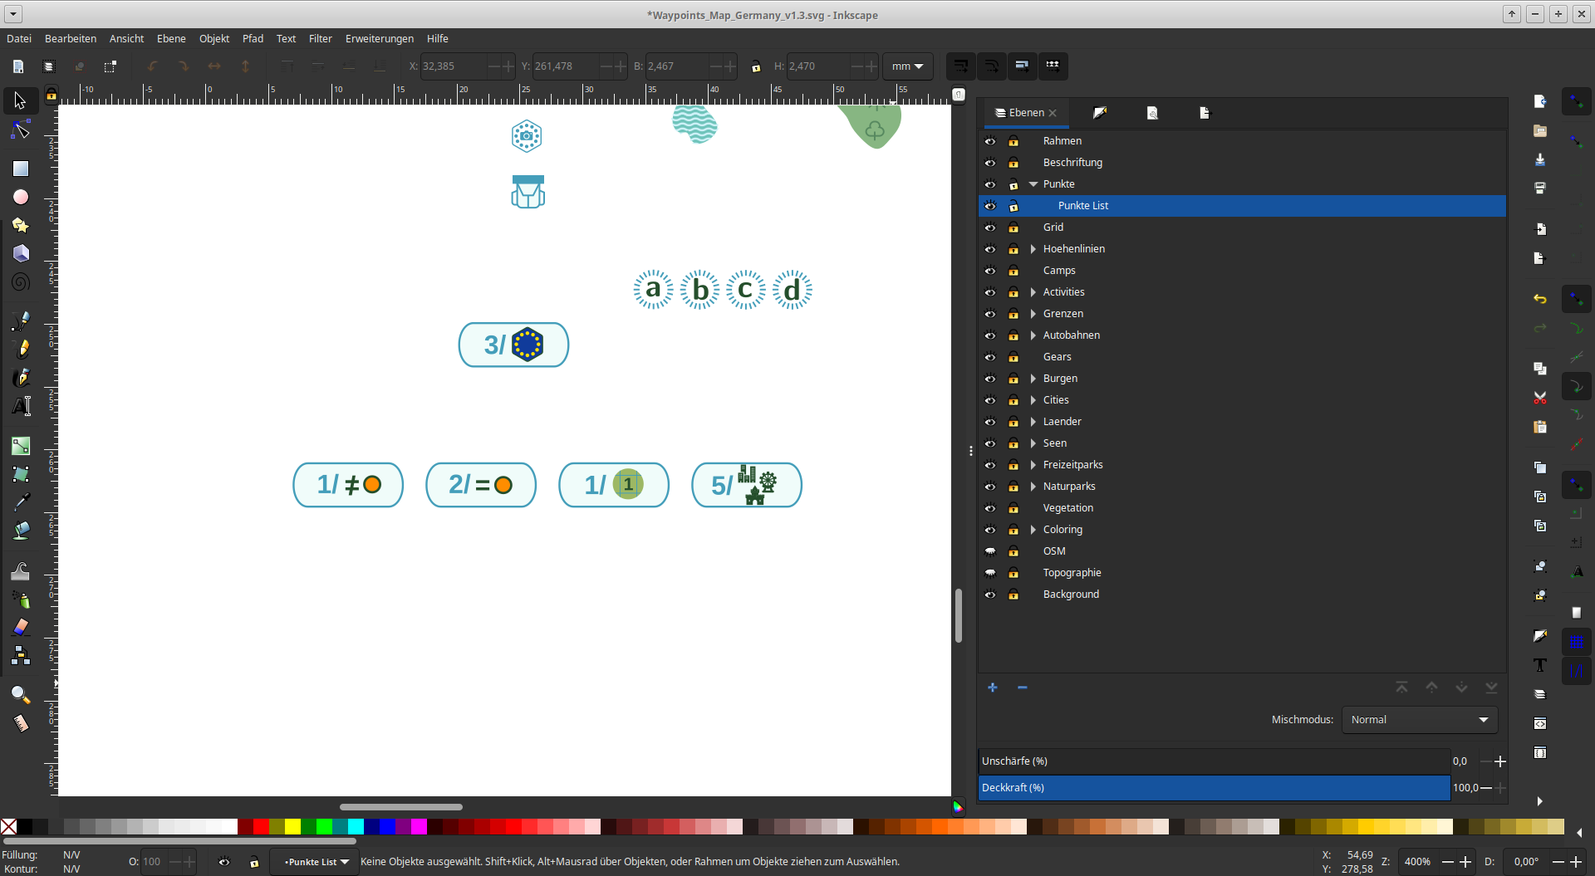
Score 1 points for each different Grid Square visited by the route on this hikes.

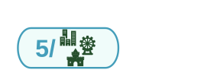
You score 5 points for each set of City, Castle, and Fun Park you have visited on this hike.

Scoring

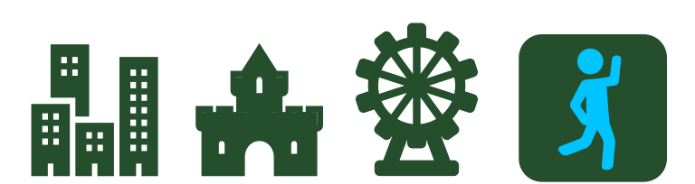
Cities, Castles, Fun Parks, and Leisure Activities Score points for each track equal to the highest number circled on the corresponding track.

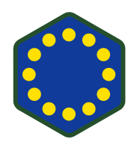
EU Sum up all points on the EU Country track and score this many points.

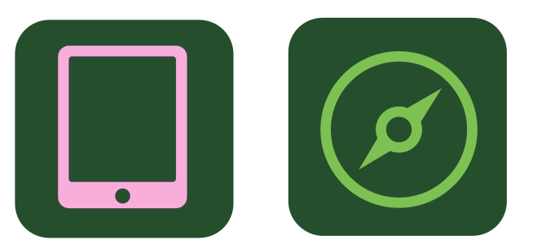
Lookout and Gears Score 5 or 15 points for each track in which you have circled 4 or 5 spaces.

Journal Entries Score points equal to the sum of all your journal entries.
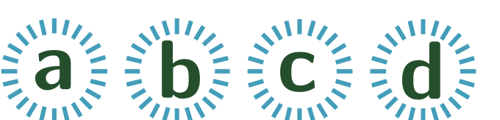
Goal Score points depending on the goal that was chosen at the beginning of the game.

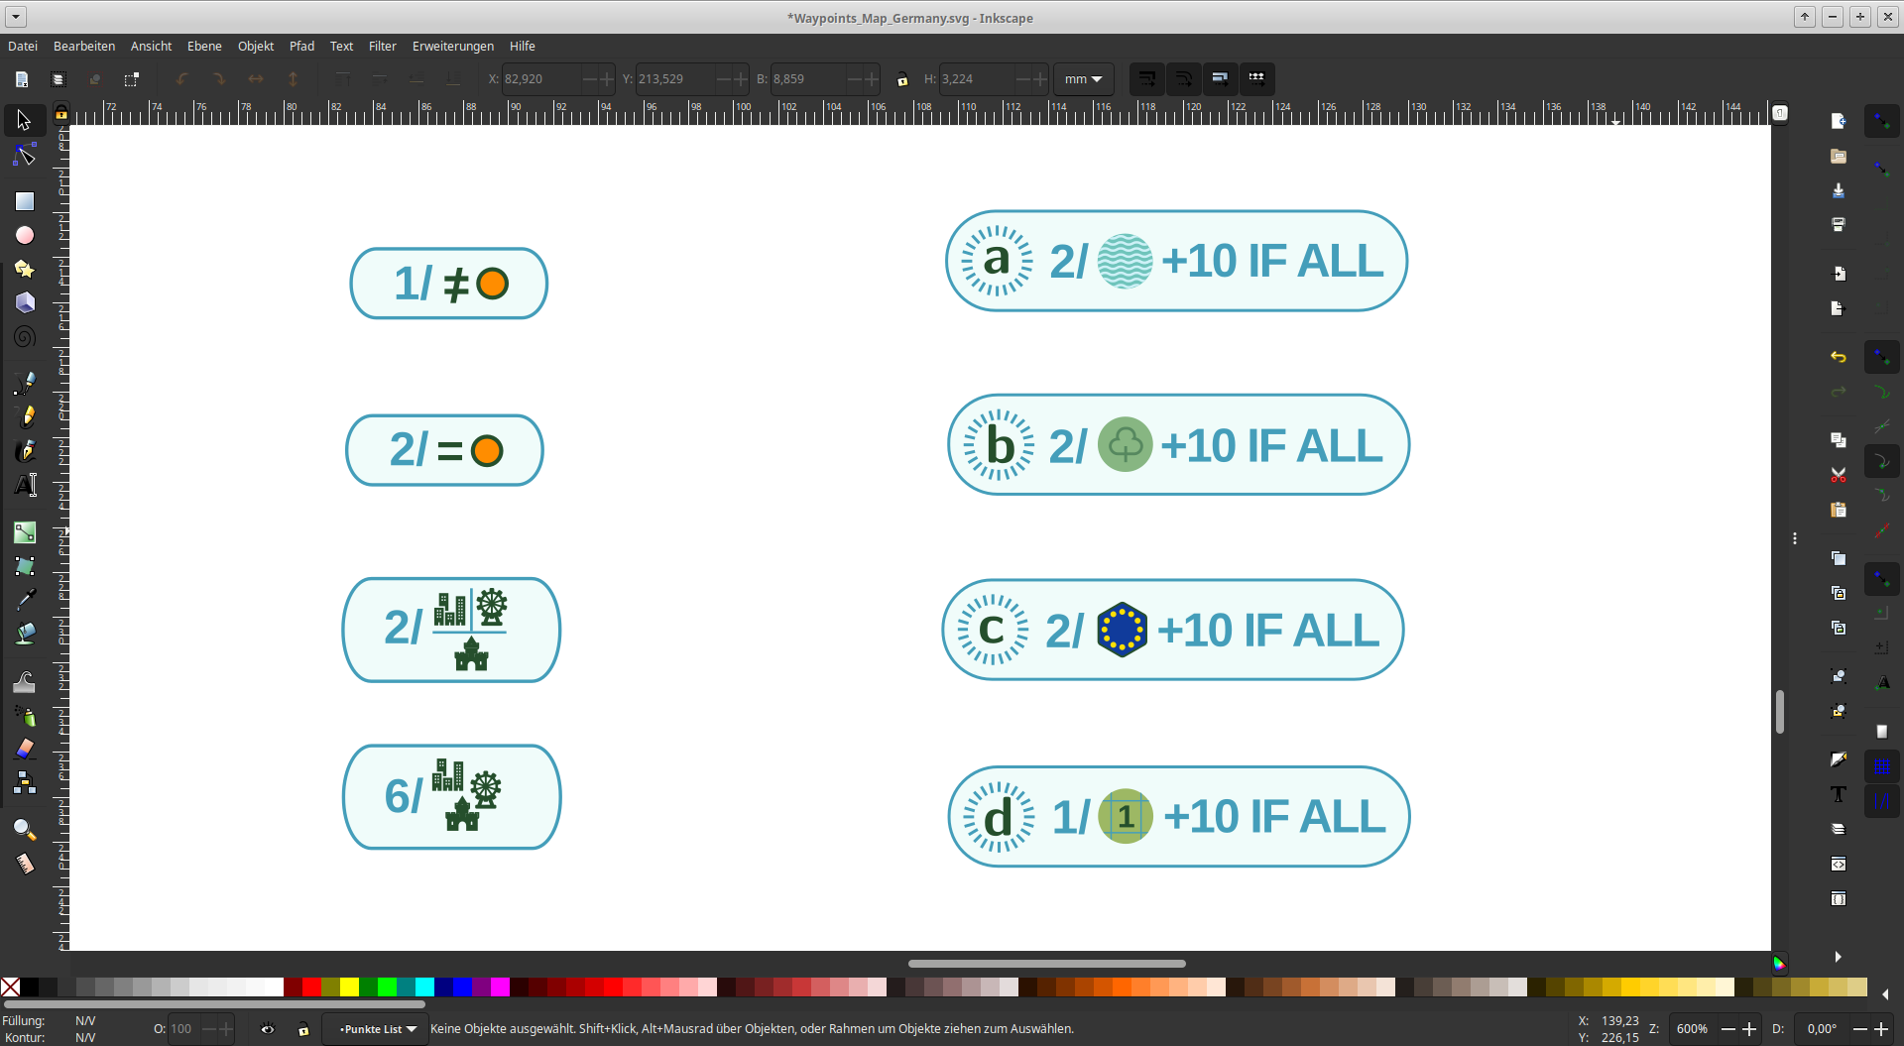
Score 2 points for each different lake you have visited, plus an additional 10 points for visiting all 8 lakes.

Score 2 points for each different national park you have visited, plus an additional 10 points for visiting all 10 national park.

Score 2 points for each EU Country you have visited or seen, plus an additional 10 points for visiting all 9 neighboring countries.

Score 1 point for each different Grid Square visited by the route on your hikes, plus an additional 10 points for visiting all 23 Grid Squares.

Note: At the right lower corner (next to the water bottles) one Grid line is missing intentionally.
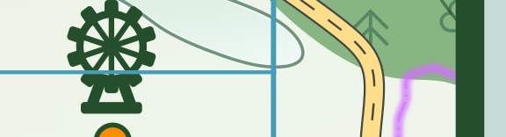
missing on purpose

Changelog

V1.3, 24.01.2024:
- changed Journal entry 3 to grid squares
- changed Journal entry 4 to give only 5 points instead of 6
- added months and seasons to Weather track
- added Autobahn numbering
- made country border a bit darker
- made Autobahn a bit lighter
- made sea more blue :)
- clarified rules at some points
- improved black and white version for more contrast

V1.2, 22.01.2024:
- added more gridlines
- crossing Autobahn costs 1 movement point
- connected Rügen with mainland (there is a street in reality)
- removed country border on coast since there is no border
- added new Autobahn to north of Poland
- added values to EU Countries depending on country area
- changed Journal entry 3 to adress EU countries
- reshaped some height lines, lakes, forest etc. for better visability

V1.1, 20.01.2024:
- changed lookout and camera to tablet internet search
- added immediate bonus arrows (top and bottom) to EU photo bonus
- reshaped some height lines, lakes, forest etc. for better visability

V1.0 (Initial Release), 18.01.2024
Background Information
All Waypoints and Features on the map, as well as the borders and the autobahn are based on the position and look of real world Germany. I just needed to adjust them a little bit sometimes if there was some overlapping of elements.

Since you might want to learn something about Germany, here is the list of the different elements used in the game (using their real German name, from North to South, West to East).

Cities
Hamburg
Magdeburg
Berlin
Düsseldorf
Dresden
Frankfurt
Nürnberg
Stuttgart
München

Castles
Schloss Glücksburg
Schloss Schwerin
Schloss Oldenburg
Schloss Moyland
Wartburg
Festung Königstein
Burg Eltz
Burg Hohenzollern
Schloss Neuschwanstein

Fun Parks
Hansa-Park
Serengeti-Park
Filmpark Babelsberg
Panorama-Park
Belantis
Holiday Park
Europa-Park
Legoland Deutschland
Bayern-Park

Countries (clockwise, beginning at top)
Dänemark
Polen
Tschechische Republik
Österreich
Schweiz
Frankreich
Luxemburg
Belgien
Niederlande

Lakes
Großer Plöner See
Müritzsee
Steinhuder Meer
Halterner Stausee
Lausitzer Seenland
Edersee
Bodensee
Chiemsee

National Parks
Lüneburger Heide
Nationalpark Müritz
Naturpark Teutoburger Wald/Eggegebirge
Nationalpark Harz
Naturpark Hohes Venn-Eifel
Thüringer Wald
Naturpark Sächsische Schweiz (extended by Böhmische Schweiz in Czech Republic)
Nationalpark Hunsrück
Schwarzwald
Bayerischer Wald

